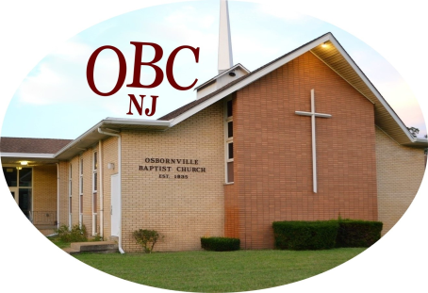

HOW WE GOT TOGETHER
One fine summer day I was driving down Drum Point Road. I saw a man standing on the front lawn of a church building. I pulled over, parked and walked up to him. He was talking to someone on the cellphone about the sprinkler system. He glanced at me sideways, wondering who in the world I was, he finished his phone call. This is the first time we had ever met.
After briefly introducing myself, I cut to the chase and let this man know that I was a pastor here in Brick, with a congregation without a building. I asked if his church, Osbornville Baptist, would be willing to rent to us. He looked at me, and this big smile came across his face. He said that they were a church with a building and a congregation, and without a permanent pastor! And, still smiling, he said “Well, why don’t you all just come on over?”
It was one of the rare moments in my life when time stood still. I wasn’t quite sure I had heard him say what he had just said. I had been fervently, pointedly asking God for years to provide us with a permanent place in which to worship and serve Him. God has his timing, and He was answering my prayer, and granting my request, as I was standing there on the front lawn of OBC.
The two churches decided that we would come over on a particular Sunday and that I would preach the sermon that day and give everybody a chance to meet me, my wife and our congregation. Afterward we had a big picnic out in the back of the church property. It was a beautiful experience. The next Sunday both congregations voted unanimously that Osbornville Baptist Church and Growing Faith Church would come together, in a harmonious cooperative effort, to advance the cause of Christ, the Good News of the Gospel. The following Sunday, August 11, 2024 we came over and have been worshiping and serving together ever since. I am personally convinced that this was literally, not figuratively, a match made in Heaven.
If you are led to join our church family and continue with us, you may very well discover areas of strength and weakness….The good the bad and the ugly. Just like there are no perfect churches. But I can tell you with confidence, after over a year of our two congregations worshiping and working together for Christ, that you will find us to be a loving bunch of people. There are many of us who have gone through some of life’s soul crushing trials and struggles. And God has graciously brought us through them. If you are going through the same struggles, who will share your burden? If you are a Christ follower and are looking for a place to serve, come join our core of dedicated serving Christians. Work with us to make a significant difference in our community.
We are, by and large, a down to earth collection of men and women who have found true love, emotional strength, and practical help from God, through faith in his Son Jesus Christ as our Lord and Savior.

